**Aim:Write a program to plot various activation functions.**

**Code:**

import matplotlib.pyplot as plt

import numpy as np

import math

1. **Sigmoid**

def sigmoid(x):

z = 1/(1 + np.exp(-x))

return z

x = np.linspace(-10, 10, 100)

plt.plot(x,sigmoid(x))

plt.xlabel("x-axis")

plt.ylabel("Sigmoid(X)")

plt.show()

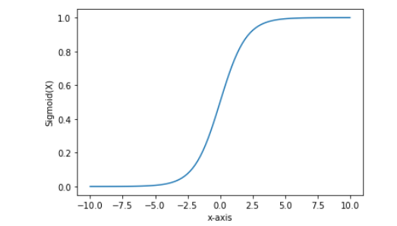

1. **Relu**

def relu(x):

return np.maximum(0,x)

x = np.linspace(-10, 10, 100)

plt.plot(x,relu(x))

plt.xlabel("x-axis")

plt.ylabel("relu(x)")

plt.show()

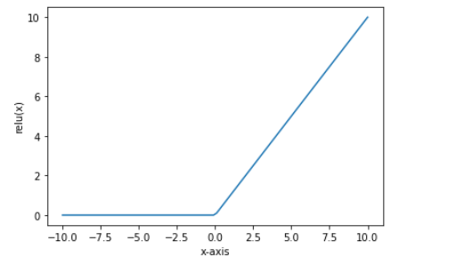

1. **Tanh**

def tanh(x):

t=(np.exp(x)-np.exp(-x))/(np.exp(x)+np.exp(-x))

return t

z=np.arange(-4,4,0.01)

plt.plot(z,tanh(z), color="#307EC7", linewidth=3, label="tanh")

plt.xlabel("x-axis")

plt.ylabel("tanh(x)")

plt.show()

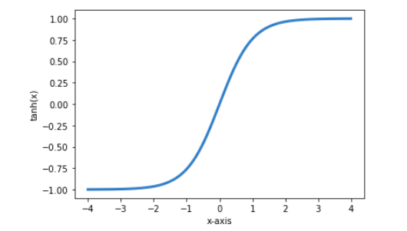

1. **Softmax**

def softmax(X):

expo = np.exp(X)

expo_sum = np.sum(np.exp(X))

return expo/expo_sum

x = np.linspace(-10, 10, 100)

plt.plot(x,softmax(x))

plt.xlabel("x-axis")

plt.ylabel("softmax(x)")

plt.show()

